- 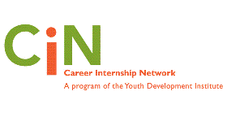

Career Internship Network

Information Packet on

High-Quality Internships

and

Positive Youth Development

- Introduction

- CIN is a network of New York City cultural institutions (museums, libraries, historical societies, community centers, hospitals, culinary institutes, theaters, nature conservancies, botanical gardens, zoos, aquariums, and the like), that run career development internship programs for high school youth. While each program is unique, excellence runs through them all. This document captures the key qualities of a sound career development internship program. They are a guideline for those initiating career development internship programs as well as existing ones that want to examine where they stand at the moment.

This document also includes an assessment of authentic work. Authentic work is an essential ingredient of an excellent internship:, it is directly related to the functioning of the organization; builds new skills; and does not primarily consist of repetitive, administrative tasks. Authentic work provides interns with the opportunity to feel they are making a difference and nurtures a sense of pride for their contribution.

Concluding this document are workplace and career-related skills and scenarios that are used as examples. These scenarios might look different in your program, but the important part is that the skill is nurtured.

You will see there is overlap throughout the different components of this document, illustrating the interrelationship that creates a high-quality career development program.
- The Basics of High-Quality Internships

A career internship is a structured real-life work experience in an actual work environment. Interns are treated as young employees who are distinguished from the rest of the staff with a structured introduction to the workplace and its accompanying professional expectations, skills, and etiquette. They have the additional benefit of working alongside a caring adult mentor who helps them initiate their career journey on a sure footing. Interns are paid, given school credit, or other form of compensation in recognition of their contribution to the organization.

- Strong internships have clear learning objectives, continual adult supervision, a work plan that interns and mentors/supervisors create together that outlines a designated series of challenging work and/or project(s) integral to the organization. The internship is based on youth development principles and staff is knowledgeable about the characteristics of adolescent developmental stages and positive youth development. The internship also provides a broad understanding of the organization and a number of occupational areas. It includes a designated time and methods for reflection in which interns think deeply and internalize their realizations and learning in order to enrich their experience.

- An essential component of a solid internship is a carefully planned and embedded evaluation based on sound methods of gathering data, analyzing and interpreting results, and using findings to refine the program.

- A successful internship program requires careful and thoughtful planning, and a program coordinator who provides ongoing contact and support to both the mentor and interns.
- High-Quality Internships

- Self-Assessment Check List

- You can use this self-assessment to discover your program’s strengths and/or areas for initiating or improvement.

- ___ carefully planned set of comprehensive experiences based on youth development principles, an understanding of teenage developmental stages, and key components necessary for career development

- ___ based on positive youth development in which interns are seen, treated, and recognized as assets; provides opportunities to shape their own learning and uses their existing skills to benefit the organization

- ___ interns develop and improve skills in goal and time management, independent and team work, communication, leadership, as well as self direction and initiative

- ____ embedded sound evaluation that measures program’s success in relationship to its goals and outcomes that becomes the basis for changes and/or development of new opportunities

- ___ successful transmission of expectations, articulated actions to support anyone struggling with them, and carries out pre-understood ultimate consequences

- ___ thorough recruitment and training of mentors who work one-on-one with interns. Mentor training includes an overview and expectations, but likewise specifically addresses the role of a mentor, how to work with youth at their developmental stage, and the way to create and assign authentic work

- ___ caring and attentive mentors who nurture a trusting two-way relationship, provides an inside-view into their daily work life and the environment around them, and help their intern set personal and career- goals

- ___ authentic work that is of true value to the organization and is planned, comprehensive, teaches entry and higher-level work skills, problem solving, and critical thinking. At the beginning of the program, the mentor-intern team, with program coordinator support, outline a flexible, but detailed plan that describes the specific work for each point throughout the program that consists of related tasks and/or project that has a minimal amount of administrative or repetitive tasks; deadlines; and a concrete description of what success looks like

- ___ physical environment and interactions that help youth feel welcomed and part of the organization and/or department

- ___ teaches and requires appropriate behavior to succeed in the workplace, and has pre-determined consequences

- ___ designated times for oral and written deep reflection so interns internalize their learning and realizations about their experiences, and relate them to their career plans

- ___ encouragement of and time for questions

- ___ cultivation of interns’ sense of ownership and pride in their work

- ___ a micro and macro perspective of the organization, and intern’s place within it

- ___ regular, planned meetings to:
- . review and reflect on progress of work, and identify next steps
- . provide positive reinforcement
- . support to help intern improve work, if applicable
- . identify possible additional experiences that broaden intern’s understanding of careers and the work world
- . review intern’s goals for the internship and her or his future

- ___ professional staff in different fields share their personal career journeys, details about their daily work, how they made and currently make decisions, and ways they handle challenges and strategies to meet them

- ___ career development workshops (such as workplace readiness, college selection and application, resume and cover letter writing, interviewing skills, job searches, etc.)

- ___ guidance in initiating a career journey action plan and intention of a professional career network

- ___ official closure of joint review about what was learned and accomplished both in general and in relationship to the team’s predetermined goals; and celebration and expression of appreciation for the intern’s contribution

- ___ continued support, connection, and opportunities for contribution to the program/organization in the future
- What Does Authentic Work Look Like?

- The following is a checklist of quality professional work for youth that helps prepare them for future success.

- ___ clear goals, expectations, and a specific description of what evidence meeting these goals would look like; all of which are articulated and understood upfront

- ___ authentic work, which is challenging, improves critical thinking, introduces new skills, is useful to the organization, and has a minimal amount of menial/repetitive tasks, and experiences that include and build off skills the intern already brings to the endeavor

- ___ recognizable beginning, middle, and end that logically builds on itself rather than being a purely repetitive and/or unrelated administrative tasks

- ___ opportunities to work in a team as well as independently, and to take on leadership roles and demonstrate self-initiation

- ___ designated times for intern self-assessment as well as mentor feedback on the work’s progress, praise given for what is well done, and supportive corrections for improvement, if applicable

- ___ builds a sense of pride in self and ownership of the work, and recognition of its value to the organization

- Workplace and Career-Related Skills

- Initiative and Self Direction Examples
- Manage Goals and Time | - Set goals with concrete success criteria  - Balance short-term and strategic long-term goals  - Utilize time and manage workload efficiently | - A mentor assigns her intern a rather long data processing project that requires a number of steps and tasks, and has a time-sensitive due date. In addition to describing what the finished project should look like, the mentor explains the reason for the work and its relevance to the organization. The intern double checks with her mentor that he understands exactly what to do. The intern manages his time effectively and completes the work successfully, and on deadline.
- Work Independently | - Monitor, define, prioritize and complete tasks without direct oversight | - Using the above scenario, the intern asks his mentor any necessary questions for clarity, and then afterwards, feeling well prepared, successfully completes the project on his own.
- Be Self-directed Learners | - Go beyond basic mastery of skills and/or curriculum to explore and expand one’s own learning and opportunities to gain expertise  - Demonstrate initiative to advance skill levels towards a professional level  - Demonstrate commitment to learning as a lifelong process  - Reflect critically on past experiences in order to inform future progress | - A mentor trains her intern on the basics of a software program. After becoming familiar with the program, the intern explores what else the software can do. The intern discovers there might be a better way to use the program and explains it to her mentor, who agrees and says she should put her suggestion into action.  - Later, writing in her journal, the intern uses the provided 3-part reflection sentence starter in the following manner:  - What I realize about my work today…"is that I’m really glad I discovered what else the software could do”  - because…"it felt great when my mentor said that my method helped me complete the job faster than she expected.”  - In the future…“whenever my mentor teaches me something new I’ll see if it can improved so the work is better.”

- Communication and Teamwork Examples
- Interact Effectively with Others | - Know when it is appropriate to listen and when to speak  - Conduct themselves in a respectable, professional manner | - A mentor is giving her intern constructive feedback on how to improve his work. The intern listens carefully, doesn’t interrupt, and repeats back his understanding of what she said, before calmly responding. At the end of the conversation, the mentor compliments her intern for handling the situation in a professional and mature manner.
- Work Effectively in Diverse Teams | - Respect differences and work effectively with people from a range of social, cultural and professional backgrounds  - Respond open-mindedly to different ideas and values  - Leverage social and cultural differences to create new ideas and increase both innovation and quality of work  - Identify roles in a team and identify how to best use their skills to help the team meet its objectives | - In a workshop on teamwork and the roles people play in a team, small groups of interns are assigned different scenarios. Each group presents its scene a number of times so that everyone can rotate through all the different roles (leader, note taker, negotiator, planner, etc.). Afterward, each intern identifies the skills she or he thinks are necessary for each role, and assesses those she or he did well, and what to work on if they need to improve them.

- Productivity and Accountability Examples
- Manage Projects | - Set and meet goals, even in the face of obstacles and competing pressure  - Prioritize, plan and manage work to achieve the intended result | - The intern successfully uses a daily planner for the week that details what he needs to do each day in order to handle her family responsibilities, school work, college prep, school play rehearsals, and dates with friends.
- Produce Results | - Demonstrate additional attributes associated with producing high-quality products including the abilities to:  - Work positively and ethically  - Multi-task  - Participate actively, as well as be reliable and punctual  - Be accountable for results | - On a final evaluation a mentor wrote that his intern was always eager to do anything, asked questions, did her work correctly and on time. The mentor also made special note that one day when he was out, his intern after completing the work he had left for her decided to ask other staff if she could be of help for the rest of the day.

- Leadership and Responsibility
- Guide and Lead Others | - Use interpersonal and problem-solving skills to influence and guide others toward a goal  - Leverage strengths of others to accomplish a common goal  - Inspire others to reach their very best via example and selflessness  - Demonstrate integrity and ethical behavior in using influence and power | - When working with her group their final presentation, the intern takes a moment to think about the other members’ particular skills and different personalities. She incorporates her thoughts into her suggestions for how everyone might participate in the planning process, and then respects people’s response to her ideas.
- Be Responsible to Others | - Act responsibly with the interests of the larger community in mind | - During a three-month group project, an intern unexpectedly has to miss the next week meeting. Despite her packed schedule, she doesn’t want to hold up the group so forgoes her friend’s weekend party, and instead completes the work she responsible for, and gets it to the team leader before leaving town.

The Youth Development Institute
Framework for Youth Development

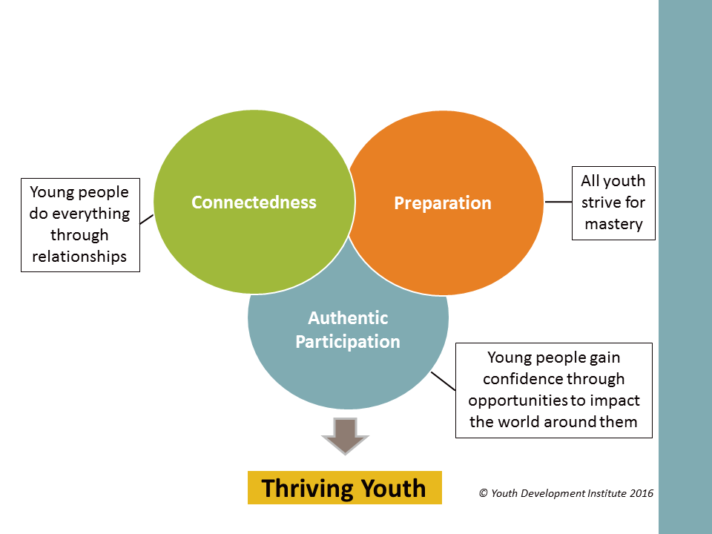
Connectedness

Definition: Cultivating positive, mutual relationships.
Premise: Young people do everything through relationships
Principles:
Promoting Connectedness means…
- Actively promoting healthy relationship building with peers, adults, and families.
- Responding to youths’ social contexts including family, schools, peers, and (social and) political realities.
- Creating a safe and supportive space where youth can bring their whole selves and discover who they are.
- Cultivating partnerships with the adults who are best positioned to contribute to their development.

Preparation

Definition: Preparation is the process of getting ready for personal, academic, social and professional accomplishment and mastery.
Premise: All youth strive for mastery
Principles:
Promoting Preparation means…
- Staff have an obligation to maintain expectations with a compassionate, non-judgmental and encouraging spirit.
- Promoting the cultivation of positive relationships as the foundation of mastery in all areas.
- Building a culture of high expectations that are realistic and for all young people
- Creating scaffolded opportunities to practice skills, confront fears, learn from mistakes, and experience success.
- Creating opportunities for youth and staff to reflect on, assess and celebrate progress.
- Helping youth discover their own sparks/assets and strive for goals and values that are meaningful to them.
- Preparing young people to recognize and navigate systemic barriers to achievement
- Equipping young people with skills to develop positive interactions in all spheres.

Authentic Participation

Definition: Building confidence and affirming competence through opportunities.
Premise: Young people gain confidence through opportunities to impact the world around them.
Principles:
Promoting Authentic Participation means…
- Structuring the environment so that young people can explore the world around them and understand their role in affecting it.
- Recognizing that young people’s ideas and concerns have inherent value.
- Creating opportunities for youth to make meaningful decisions.
- Building young people’s capacities to lead and take action.
- Trusting and supporting young people to step into defined roles with real responsibilities.

Principles of Youth Development

Clear and High Expectations
- Information is communicated in a straight forward way and is sufficient to enable young people to make informed decisions.
- A shared understanding -- of why the young adult is in the program and what the program can offer -- is established.
- The belief that young adults can succeed and meet their aspirations, wants and personal expectations is fostered among staff and young people.
- An understanding of roles, boundaries, norms, rules and values is a process that occurs over time.

Caring Adult Relationships
- Young adults are viewed holistically and can see multiple opportunities to meet their own goals.
- There is at least one adult who works closely with and supports each participant.
- Personal histories and strengths are acknowledged.
- The importance and role of caring adults is operationalized in the structure of the program.
- Young people’s growth and progress is acknowledged in caring and productive ways.

Competence and Mastery
- Participation is purposeful and focused on learning and growth.
- Appropriate educational supports maximize student learning and are responsive to young adult skill levels.
- Instruction links new learning to existing knowledge and life experiences.
- Opportunities for students to practice and demonstrate accomplishments are developed.
- Young adults are at the center of their on-going development.

Safety
- Staff creates a welcoming environment.
- Young adults experience physical and psychological safety in the program.
- Young adults feel a sense of belonging within a community of learners.

Engaging Activities
- Program activities are authentic and meaningful.
- Instruction is relevant to young adults and makes connections to their life experiences.
- Activities enable young adults to understand “self” in the context of the world at large.
- Young adults initiate activities and use their strengths.
- Staff work together on how to make the activities in the classroom and program interesting to young people.

Young Adult Voice and Participation

- Young adults use their literacy skills to benefit others.
- Young adults use their individual and collective voice to influence program design and activities.

Continuity

- Consistency -- of expectations, messages and staff relationships -- is maintained.
- Appropriate support services are provided at every stage of the program.

